

HACKFEST 2025
Dehradun, India

Date of Event: 24th April 2024

School of Computer Science

Table of Contents
1.0. Introduction- about the event 3
2.0. Guests/ Speaker/ Visitor Details 3
3.0. Major Take Aways 3
4.0. Budget and Expenses Breakup (Optional) 3
5.0. Geotagged Photos 3
6.0. Participants’ Feedback 4
7.0. Annexures 12
7.1. Brochure of Event 12
7.2. Event Communication Details 12
7.3. Attendance sheet 12
7.4. Participants’ Feedback 12

- Introduction- about the event
Hackfest 2025 was successfully organized at the School of Computer Science, UPES, in collaboration with Mile2 Asia, as part of the continuous learning series on Cybersecurity and Ethical Hacking. The event served as a platform for cybersecurity enthusiasts to explore advanced hacking techniques, digital forensics, and security operations through interactive hands-on sessions conducted by industry experts. More than 100+ Cyber Hacking aspirants from the B.Tech Cyber Security & Forensics (CSF) program participated enthusiastically. The event aimed to bridge the gap between academic learning and real-world cybersecurity practices by providing exposure to globally recognized security frameworks, threat detection methodologies, and penetration testing approaches. The session witnessed immense engagement from students and faculty members, who appreciated the knowledge shared by the expert team from Mile2 Asia. The collaborative efforts and team spirit showcased by the School of Computer Science demonstrated the institution’s commitment to fostering practical learning and industry partnerships in cybersecurity education.

- Guests/ Speaker/ Visitor Detail
Name | Designation | Organization
Mr. Vikram Singh Srivastava | Cybersecurity Expert | Mile2 Asia
Mr. Mayank Pandya | Technical Trainer | Mile2 Asia

- Major Take Aways
- Students gained hands-on experience in ethical hacking and vulnerability assessment.
- Industry experts from Mile2 Asia demonstrated real-world cyber-attack simulations and defense strategies.
- Enhanced understanding of offensive and defensive cybersecurity tools used in Security Operations Centers (SOC).
- Reinforced the importance of collaborative learning and team-based problem-solving in cybersecurity education.
- Strengthened the academic–industry partnership between UPES and Mile2 Asia for future cybersecurity initiatives.

- Budget and Expenses Breakup (Optional)

N/A
- Geotagged Photos (at least two)

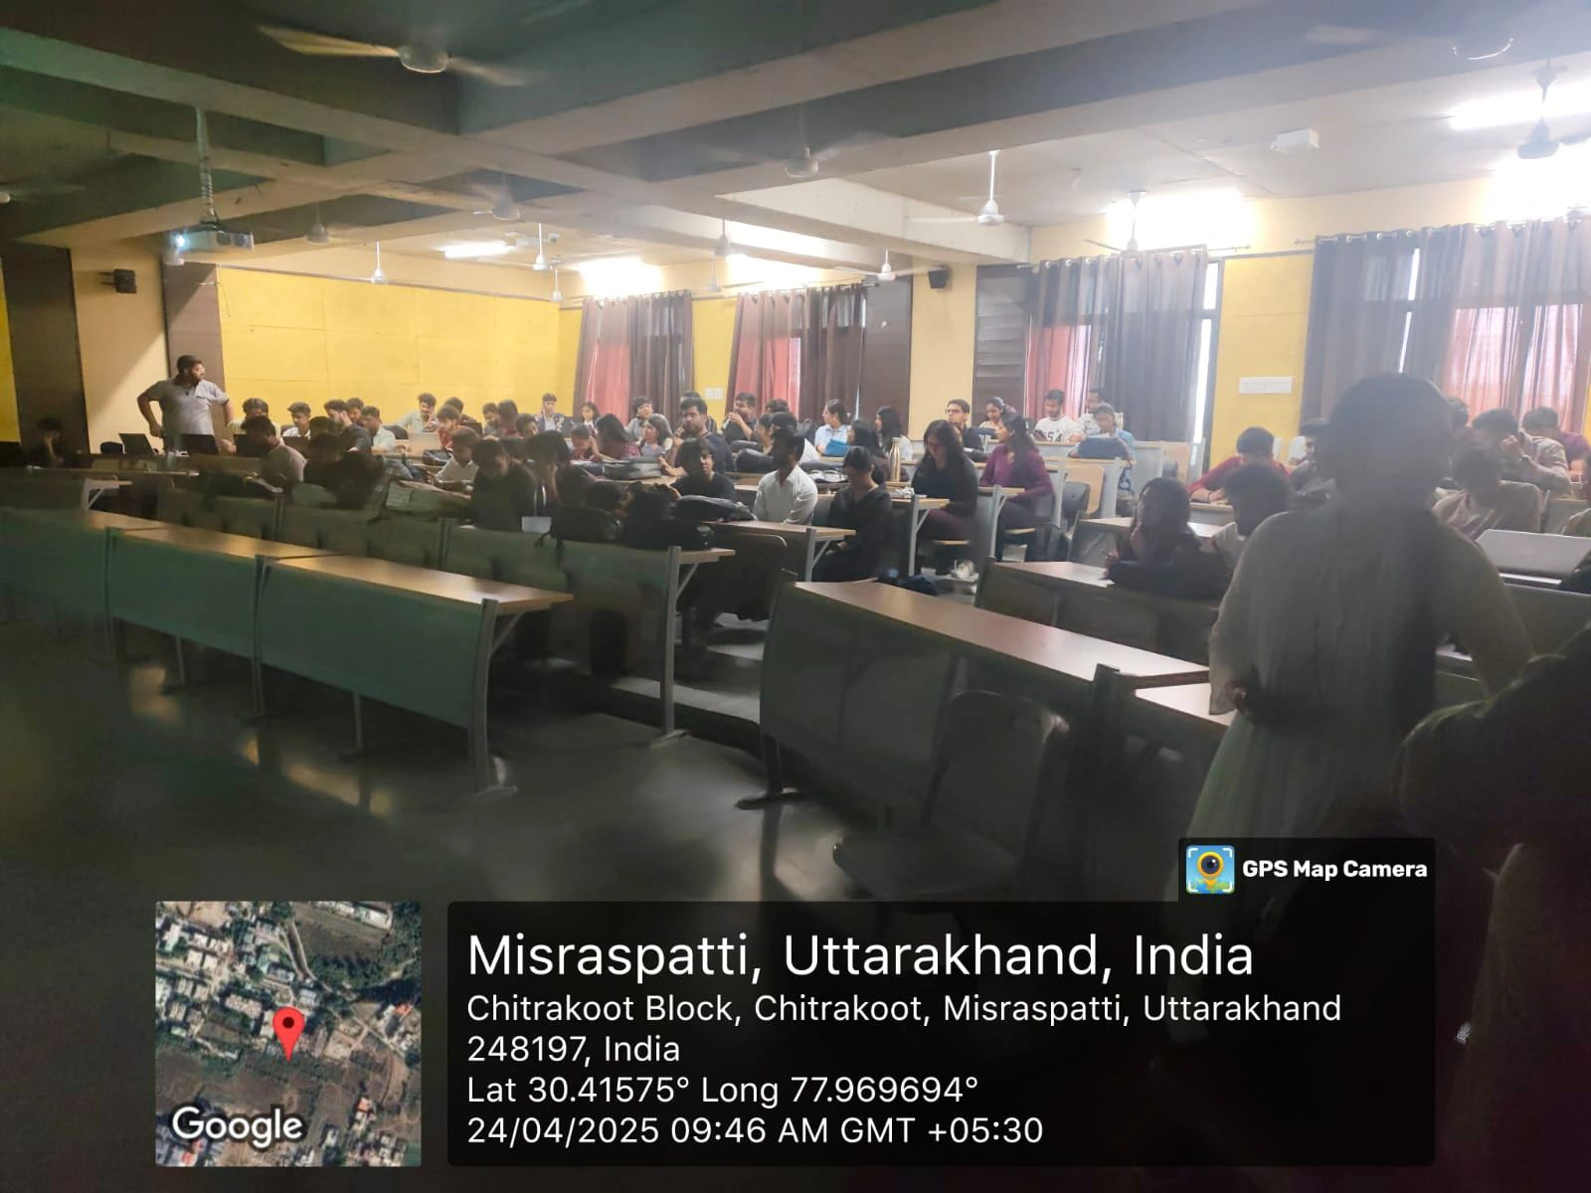
Figure 1. Event Start

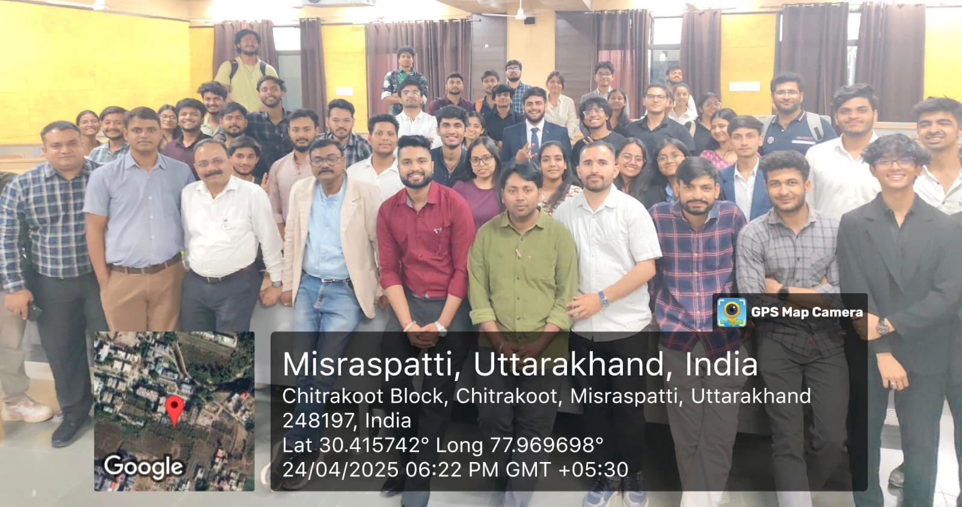
Figure 2. Event End

- Participants’ Feedback
HACKFEST 2025 has received excellent feedback from delegates in all criteria’s. Feedback attached as annexure 7.4.

Name of Participant | Category | Designation | Department / Organization | Overall Quality | Organization & Planning | Speakers’ Knowledge | Content Relevance | Recommendation
Shreya Gupta | Student | B.Tech Cyber Security | School of Computer Science, UPES | 4 Outstanding | 4 Outstanding | 4 Outstanding | 5 Excellent | Recommend
Ishita Bhatt | Student | B.Tech Cyber Security | School of Computer Science, UPES | 5 Excellent | 5 Excellent | 5 Excellent | 4 Outstanding | Highly Recommend
Garima Karki | Student | B.Tech Cyber Security | School of Computer Science, UPES | 5 Excellent | 5 Excellent | 5 Excellent | 4 Outstanding | Highly Recommend
Tanusha Sharma | Student | B.Tech Cyber Security | School of Computer Science, UPES | 5 Excellent | 5 Excellent | 5 Excellent | 5 Excellent | Highly Recommend
Abhigyan Raushan | Student | B.Tech Cyber Security | School of Computer Science, UPES | 4 Outstanding | 5 Excellent | 5 Excellent | 4 Outstanding | Highly Recommend
Radhika Na | Student | B.Tech Cyber Security | School of Computer Science, UPES | 5 Excellent | 4 Outstanding | 5 Excellent | 4 Outstanding | Highly Recommend
Swati Kumari | Student | B.Tech Cyber Security | School of Computer Science, UPES | 5 Excellent | 5 Excellent | 4 Outstanding | 5 Excellent | Highly Recommend
Siddharth Shukla | Student | B.Tech Cyber Security | School of Computer Science, UPES | 5 Excellent | 5 Excellent | 5 Excellent | 4 Outstanding | Recommend
Rachit Tyagi | Student | B.Tech Cyber Security | School of Computer Science, UPES | 4 Outstanding | 5 Excellent | 5 Excellent | 4 Outstanding | Highly Recommend
Dhruv Singh Malik | Student | B.Tech Cyber Security | School of Computer Science, UPES | 5 Excellent | 5 Excellent | 5 Excellent | 5 Excellent | Highly Recommend
Somavarampeta Sreeya Raj | Student | B.Tech Cyber Security | School of Computer Science, UPES | 5 Excellent | 4 Outstanding | 5 Excellent | 4 Outstanding | Highly Recommend
Tanisha Patel | Student | B.Tech Cyber Security | School of Computer Science, UPES | 5 Excellent | 5 Excellent | 5 Excellent | 4 Outstanding | Highly Recommend
Pranjal Rawat | Student | B.Tech Cyber Security | School of Computer Science, UPES | 4 Outstanding | 5 Excellent | 4 Outstanding | 5 Excellent | Highly Recommend
Ayza Jafri | Student | B.Tech Cyber Security | School of Computer Science, UPES | 5 Excellent | 5 Excellent | 5 Excellent | 4 Outstanding | Highly Recommend
Chehak Jindal | Student | B.Tech Cyber Security | School of Computer Science, UPES | 5 Excellent | 5 Excellent | 5 Excellent | 4 Outstanding | Recommend
Devyansh Vohra | Student | B.Tech Cyber Security | School of Computer Science, UPES | 5 Excellent | 4 Outstanding | 5 Excellent | 5 Excellent | Highly Recommend
Bhanuj Jain | Student | B.Tech Cyber Security | School of Computer Science, UPES | 4 Outstanding | 5 Excellent | 5 Excellent | 4 Outstanding | Highly Recommend
Niharika | Student | B.Tech Cyber Security | School of Computer Science, UPES | 5 Excellent | 5 Excellent | 5 Excellent | 4 Outstanding | Highly Recommend
Divyanshu Gairwal | Student | B.Tech Cyber Security | School of Computer Science, UPES | 5 Excellent | 5 Excellent | 4 Outstanding | 5 Excellent | Highly Recommend
Shreyansh Rathaur | Student | B.Tech Cyber Security | School of Computer Science, UPES | 5 Excellent | 5 Excellent | 5 Excellent | 4 Outstanding | Highly Recommend
Vijay Singh Bisht | Student | B.Tech Cyber Security | School of Computer Science, UPES | 4 Outstanding | 4 Outstanding | 5 Excellent | 4 Outstanding | Highly Recommend
Devansh Baluni | Student | B.Tech Cyber Security | School of Computer Science, UPES | 5 Excellent | 5 Excellent | 5 Excellent | 5 Excellent | Recommend
Abel John Reni | Student | B.Tech Cyber Security | School of Computer Science, UPES | 5 Excellent | 5 Excellent | 5 Excellent | 4 Outstanding | Highly Recommend
Neelkant Srivastava | Student | B.Tech Cyber Security | School of Computer Science, UPES | 5 Excellent | 5 Excellent | 5 Excellent | 4 Outstanding | Highly Recommend
Pavitra Dwivedi | Student | B.Tech Cyber Security | School of Computer Science, UPES | 4 Outstanding | 5 Excellent | 4 Outstanding | 5 Excellent | Highly Recommend
Rohit Batra | Student | B.Tech Cyber Security | School of Computer Science, UPES | 5 Excellent | 4 Outstanding | 5 Excellent | 4 Outstanding | Highly Recommend
Jai Manikalla | Student | B.Tech Cyber Security | School of Computer Science, UPES | 5 Excellent | 5 Excellent | 5 Excellent | 4 Outstanding | Highly Recommend
Mudit Kaushik | Student | B.Tech Cyber Security | School of Computer Science, UPES | 5 Excellent | 5 Excellent | 5 Excellent | 5 Excellent | Highly Recommend
Manas Dixit | Student | B.Tech Cyber Security | School of Computer Science, UPES | 4 Outstanding | 5 Excellent | 5 Excellent | 4 Outstanding | Recommend
Kshitij Amrit | Student | B.Tech Cyber Security | School of Computer Science, UPES | 5 Excellent | 5 Excellent | 5 Excellent | 4 Outstanding | Highly Recommend
Raghav Joshi | Student | B.Tech Cyber Security | School of Computer Science, UPES | 5 Excellent | 4 Outstanding | 4 Outstanding | 5 Excellent | Highly Recommend
Kashish Rathour | Student | B.Tech Cyber Security | School of Computer Science, UPES | 5 Excellent | 5 Excellent | 5 Excellent | 4 Outstanding | Highly Recommend
Adwita | Student | B.Tech Cyber Security | School of Computer Science, UPES | 4 Outstanding | 5 Excellent | 5 Excellent | 4 Outstanding | Highly Recommend
Shridhar Raj | Student | B.Tech Cyber Security | School of Computer Science, UPES | 5 Excellent | 5 Excellent | 5 Excellent | 5 Excellent | Highly Recommend
Vedanshi Joshi | Student | B.Tech Cyber Security | School of Computer Science, UPES | 5 Excellent | 5 Excellent | 5 Excellent | 4 Outstanding | Highly Recommend
Karan Kumar | Student | B.Tech Cyber Security | School of Computer Science, UPES | 5 Excellent | 4 Outstanding | 5 Excellent | 4 Outstanding | Recommend
Shivangi Arya | Student | B.Tech Cyber Security | School of Computer Science, UPES | 4 Outstanding | 5 Excellent | 4 Outstanding | 5 Excellent | Highly Recommend
Amrit Raj Garg | Student | B.Tech Cyber Security | School of Computer Science, UPES | 5 Excellent | 5 Excellent | 5 Excellent | 4 Outstanding | Highly Recommend
Het Mehta | Student | B.Tech Cyber Security | School of Computer Science, UPES | 5 Excellent | 5 Excellent | 5 Excellent | 4 Outstanding | Highly Recommend
Parth Sharma | Student | B.Tech Cyber Security | School of Computer Science, UPES | 5 Excellent | 5 Excellent | 5 Excellent | 5 Excellent | Highly Recommend
Vanshika Verma | Student | B.Tech Cyber Security | School of Computer Science, UPES | 4 Outstanding | 4 Outstanding | 5 Excellent | 4 Outstanding | Highly Recommend
Kripa Khandelwal | Student | B.Tech Cyber Security | School of Computer Science, UPES | 5 Excellent | 5 Excellent | 5 Excellent | 4 Outstanding | Highly Recommend
Chiranshu Agrawal | Student | B.Tech Cyber Security | School of Computer Science, UPES | 5 Excellent | 5 Excellent | 4 Outstanding | 5 Excellent | Recommend
Vansh Nathwani | Student | B.Tech Cyber Security | School of Computer Science, UPES | 5 Excellent | 5 Excellent | 5 Excellent | 4 Outstanding | Highly Recommend
Divyanshu Arora | Student | B.Tech Cyber Security | School of Computer Science, UPES | 4 Outstanding | 5 Excellent | 5 Excellent | 4 Outstanding | Highly Recommend
Deepti Gupta | Student | B.Tech Cyber Security | School of Computer Science, UPES | 5 Excellent | 4 Outstanding | 5 Excellent | 5 Excellent | Highly Recommend
Nityavardhan Singh | Student | B.Tech Cyber Security | School of Computer Science, UPES | 5 Excellent | 5 Excellent | 5 Excellent | 4 Outstanding | Highly Recommend
Aadesh Shekhar | Student | B.Tech Cyber Security | School of Computer Science, UPES | 5 Excellent | 5 Excellent | 5 Excellent | 4 Outstanding | Highly Recommend
Jahnavi Saxena | Student | B.Tech Cyber Security | School of Computer Science, UPES | 4 Outstanding | 5 Excellent | 4 Outstanding | 5 Excellent | Highly Recommend
Palak Garg | Student | B.Tech Cyber Security | School of Computer Science, UPES | 5 Excellent | 5 Excellent | 5 Excellent | 4 Outstanding | Recommend
Ronak Singh | Student | B.Tech Cyber Security | School of Computer Science, UPES | 5 Excellent | 4 Outstanding | 5 Excellent | 4 Outstanding | Highly Recommend
Abhinav Patel | Student | B.Tech Cyber Security | School of Computer Science, UPES | 5 Excellent | 5 Excellent | 5 Excellent | 5 Excellent | Highly Recommend
Divyanshi Chandani | Student | B.Tech Cyber Security | School of Computer Science, UPES | 4 Outstanding | 5 Excellent | 5 Excellent | 4 Outstanding | Highly Recommend
Priyanshi Singhi | Student | B.Tech Cyber Security | School of Computer Science, UPES | 5 Excellent | 5 Excellent | 5 Excellent | 4 Outstanding | Highly Recommend
Vansh Malik | Student | B.Tech Cyber Security | School of Computer Science, UPES | 5 Excellent | 5 Excellent | 4 Outstanding | 5 Excellent | Highly Recommend
Manya Nayak | Student | B.Tech Cyber Security | School of Computer Science, UPES | 5 Excellent | 4 Outstanding | 5 Excellent | 4 Outstanding | Highly Recommend
Divyanshu Mishra | Student | B.Tech Cyber Security | School of Computer Science, UPES | 4 Outstanding | 5 Excellent | 5 Excellent | 4 Outstanding | Recommend
Kartik Arora | Student | B.Tech Cyber Security | School of Computer Science, UPES | 5 Excellent | 5 Excellent | 5 Excellent | 5 Excellent | Highly Recommend
Palak Aeron | Student | B.Tech Cyber Security | School of Computer Science, UPES | 5 Excellent | 5 Excellent | 5 Excellent | 4 Outstanding | Highly Recommend
Ayush Dhiman | Student | B.Tech Cyber Security | School of Computer Science, UPES | 5 Excellent | 5 Excellent | 5 Excellent | 4 Outstanding | Highly Recommend
Pranay Ahluwalia | Student | B.Tech Cyber Security | School of Computer Science, UPES | 4 Outstanding | 4 Outstanding | 4 Outstanding | 5 Excellent | Highly Recommend
Nitya Gupta | Student | B.Tech Cyber Security | School of Computer Science, UPES | 5 Excellent | 5 Excellent | 5 Excellent | 4 Outstanding | Highly Recommend
Manisha Mehra | Student | B.Tech Cyber Security | School of Computer Science, UPES | 5 Excellent | 5 Excellent | 5 Excellent | 4 Outstanding | Highly Recommend
Neo Gonsalves | Student | B.Tech Cyber Security | School of Computer Science, UPES | 5 Excellent | 5 Excellent | 5 Excellent | 5 Excellent | Recommend
Aayush Agrawal | Student | B.Tech Cyber Security | School of Computer Science, UPES | 4 Outstanding | 5 Excellent | 5 Excellent | 4 Outstanding | Highly Recommend
Rajdeep Pal | Student | B.Tech Cyber Security | School of Computer Science, UPES | 5 Excellent | 4 Outstanding | 5 Excellent | 4 Outstanding | Highly Recommend
Ambar Gairola | Student | B.Tech Cyber Security | School of Computer Science, UPES | 5 Excellent | 5 Excellent | 4 Outstanding | 5 Excellent | Highly Recommend
Pranjal Goyal | Student | B.Tech Cyber Security | School of Computer Science, UPES | 5 Excellent | 5 Excellent | 5 Excellent | 4 Outstanding | Highly Recommend
Harsh Vardhan Singh | Student | B.Tech Cyber Security | School of Computer Science, UPES | 4 Outstanding | 5 Excellent | 5 Excellent | 4 Outstanding | Highly Recommend
Krish | Student | B.Tech Cyber Security | School of Computer Science, UPES | 5 Excellent | 5 Excellent | 5 Excellent | 5 Excellent | Highly Recommend
Aditi Chauhan | Student | B.Tech Cyber Security | School of Computer Science, UPES | 5 Excellent | 4 Outstanding | 5 Excellent | 4 Outstanding | Recommend
Harshit Jain | Student | B.Tech Cyber Security | School of Computer Science, UPES | 5 Excellent | 5 Excellent | 5 Excellent | 4 Outstanding | Highly Recommend
Kavya Jain | Student | B.Tech Cyber Security | School of Computer Science, UPES | 4 Outstanding | 5 Excellent | 4 Outstanding | 5 Excellent | Highly Recommend
Amartya Sharma | Student | B.Tech Cyber Security | School of Computer Science, UPES | 5 Excellent | 5 Excellent | 5 Excellent | 4 Outstanding | Highly Recommend
Priyanshu Pandey | Student | B.Tech Cyber Security | School of Computer Science, UPES | 5 Excellent | 5 Excellent | 5 Excellent | 4 Outstanding | Highly Recommend
Anubhav Agrawal | Student | B.Tech Cyber Security | School of Computer Science, UPES | 5 Excellent | 4 Outstanding | 5 Excellent | 5 Excellent | Highly Recommend
Chhavi Gera | Student | B.Tech Cyber Security | School of Computer Science, UPES | 4 Outstanding | 5 Excellent | 5 Excellent | 4 Outstanding | Highly Recommend
Kattyayni Dwivedi | Student | B.Tech Cyber Security | School of Computer Science, UPES | 5 Excellent | 5 Excellent | 5 Excellent | 4 Outstanding | Recommend
Sneha Saini | Student | B.Tech Cyber Security | School of Computer Science, UPES | 5 Excellent | 5 Excellent | 4 Outstanding | 5 Excellent | Highly Recommend
Aikagra Gupta | Student | B.Tech Cyber Security | School of Computer Science, UPES | 5 Excellent | 5 Excellent | 5 Excellent | 4 Outstanding | Highly Recommend
Prasha Singh | Student | B.Tech Cyber Security | School of Computer Science, UPES | 4 Outstanding | 4 Outstanding | 5 Excellent | 4 Outstanding | Highly Recommend
Viswas Pp | Student | B.Tech Cyber Security | School of Computer Science, UPES | 5 Excellent | 5 Excellent | 5 Excellent | 5 Excellent | Highly Recommend
Aryan Singh Shaktawat | Student | B.Tech Cyber Security | School of Computer Science, UPES | 5 Excellent | 5 Excellent | 5 Excellent | 4 Outstanding | Highly Recommend
Anshika Sharma | Student | B.Tech Cyber Security | School of Computer Science, UPES | 5 Excellent | 5 Excellent | 5 Excellent | 4 Outstanding | Highly Recommend
Paras Bhardwaj | Student | B.Tech Cyber Security | School of Computer Science, UPES | 4 Outstanding | 5 Excellent | 4 Outstanding | 5 Excellent | Recommend
Kushal Singhal | Student | B.Tech Cyber Security | School of Computer Science, UPES | 5 Excellent | 4 Outstanding | 5 Excellent | 4 Outstanding | Highly Recommend
Mannat | Student | B.Tech Cyber Security | School of Computer Science, UPES | 5 Excellent | 5 Excellent | 5 Excellent | 4 Outstanding | Highly Recommend
Vedika Rai | Student | B.Tech Cyber Security | School of Computer Science, UPES | 5 Excellent | 5 Excellent | 5 Excellent | 5 Excellent | Highly Recommend
Khushboo Ratnani | Student | B.Tech Cyber Security | School of Computer Science, UPES | 4 Outstanding | 5 Excellent | 5 Excellent | 4 Outstanding | Highly Recommend
Divyansh Upadhyay | Student | B.Tech Cyber Security | School of Computer Science, UPES | 5 Excellent | 5 Excellent | 5 Excellent | 4 Outstanding | Highly Recommend
Katyayini Singh | Student | B.Tech Cyber Security | School of Computer Science, UPES | 5 Excellent | 4 Outstanding | 4 Outstanding | 5 Excellent | Highly Recommend
Rahul Kumar | Student | B.Tech Cyber Security | School of Computer Science, UPES | 5 Excellent | 5 Excellent | 5 Excellent | 4 Outstanding | Recommend
Soumya Shrivastava | Student | B.Tech Cyber Security | School of Computer Science, UPES | 4 Outstanding | 5 Excellent | 5 Excellent | 4 Outstanding | Highly Recommend
Suhani Saini | Student | B.Tech Cyber Security | School of Computer Science, UPES | 5 Excellent | 5 Excellent | 5 Excellent | 5 Excellent | Highly Recommend
Azal | Student | B.Tech Cyber Security | School of Computer Science, UPES | 5 Excellent | 5 Excellent | 5 Excellent | 4 Outstanding | Highly Recommend
Lakshya Lakshya | Student | B.Tech Cyber Security | School of Computer Science, UPES | 5 Excellent | 4 Outstanding | 5 Excellent | 4 Outstanding | Highly Recommend
Harshit | Student | B.Tech Cyber Security | School of Computer Science, UPES | 4 Outstanding | 5 Excellent | 4 Outstanding | 5 Excellent | Highly Recommend
Aditya Kumar | Student | B.Tech Cyber Security | School of Computer Science, UPES | 5 Excellent | 5 Excellent | 5 Excellent | 4 Outstanding | Highly Recommend
Tushar Arora | Student | B.Tech Cyber Security | School of Computer Science, UPES | 5 Excellent | 5 Excellent | 5 Excellent | 4 Outstanding | Recommend
Shubham Sahu | Student | B.Tech Cyber Security | School of Computer Science, UPES | 5 Excellent | 5 Excellent | 5 Excellent | 5 Excellent | Highly Recommend
Lucky Singh | Student | B.Tech Cyber Security | School of Computer Science, UPES | 4 Outstanding | 4 Outstanding | 5 Excellent | 4 Outstanding | Highly Recommend
Prabhat Verma | Student | B.Tech Cyber Security | School of Computer Science, UPES | 5 Excellent | 5 Excellent | 5 Excellent | 4 Outstanding | Highly Recommend
Atishay Jain | Student | B.Tech Cyber Security | School of Computer Science, UPES | 5 Excellent | 5 Excellent | 4 Outstanding | 5 Excellent | Highly Recommend

- Annexures (to be attached along with report)
  - Brochure of Event

Attached as Annexure 7.1
  - Event Communication Details

abhardwaj@ddn.upes.ac.in

keshav.sinha@ddn.upes.ac.in
  - Attendance sheet

Attached as Annexure 7.3A, 7.3B
  - Participants’ Feedback

Attached as Annexure 7.4

Dr. Akashdeep Bhardwaj
Professor & Head @ Center For Cybersecurity
School of Computer Science, UPES Dehradun, India

